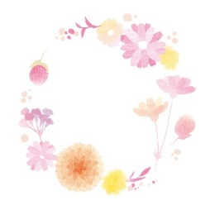
N
R

N
R

N
R

N
R

N
R

N
R

N
R

N
R

N
R

N
R

N
R

N
R

N
R

N
R

N
R

N
R

N
R

N
R

N
R

N
R

N
R

N
R

N
R

N
R

N
R

N
R

N
R

N
R

N
R

N
R

N
R

N
R

N
R

N
R

N
R

N
R

N
R

N
R

N
R

N
R

N
R

N
R

N
R

N
R

N
R

N
R

N
R

N
R

